**Artificial Intelligence**

**and Data Science Department**

OOPM / Odd Sem 2021-22 / Experiment 1

**YASH SARANG**

**DIV: D6AD  
ROLL NO: 47**

**Program 1.A**

**Aim:** To implement a program to print the roots of quadratic equations.

**Theory:**

Instance Variable: A variable declared inside the class but outside the body of the method is

called an instance variable.

Local Variable: A local variable in Java is a variable that's declared within the body of a method

Static Variable: Static variables are stored in the static memory. Variables are created when the program starts and destroyed when the program stops.

Data Types: int: 4 byte, float: 4 byte, long: 8 byte, double:8 byte.

Looping constructs:

while(true){ // code to be executed

}

**CODE:**

import java.lang.*;

import java.lang.Math;

import java.util.*;

class prime_check

{

public static void main(String args[])

{

Scanner input = new Scanner(System.in); //System.in is a standard input stream.

System.out.print("Enter the integer number to check - ");

int a= input.nextInt();

int x=0;

if (a<2)

{

System.out.println(a+" is not a Prime Number");

}

else if (a==2)

{

System.out.println(a + " is a Prime Number");

}

else

{

for(int i=2;i<=(int) a/2;i++)

{

if (a%i==0)

x++;

}

if (x>0)

{

System.out.println(a+" is not a Prime Number with "+x+" factors");

}

else

{

System.out.println(a+" is a Prime Number");

}

}

}

}

**Output Screenshot of the Code:**

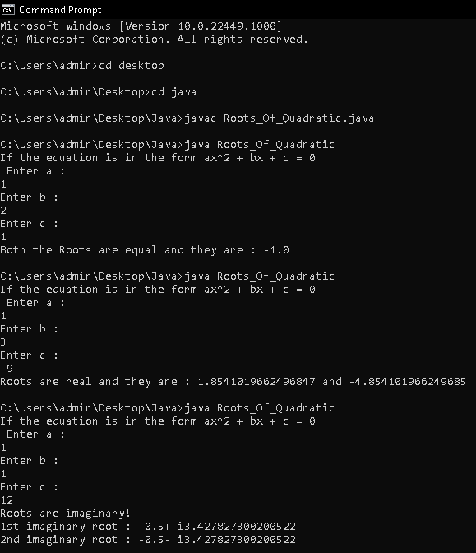

**Program 1.b**

**Aim:** To implement a program to check if the entered no. is a prime no. or not.

**Code:**

import java.lang.*;

import java.util.*;

import java.lang.Math;

class Roots_Of_Quadratic

{

public static void main(String args[])

{

byte a,b,c;

int D;

Scanner input = new Scanner(System.in);

System.out.println("If the equation is in the form ax^2 + bx + c = 0 \n Enter a : ");

a = input.nextByte();

System.out.println("Enter b : ");

b = input.nextByte();

System.out.println("Enter c : ");

c = input.nextByte();

double x1,x2;

D = (b*b)-(4*a*c);

if (D<0)

{

System.out.println("Roots are imaginary!");

x1 = (double) ((-1.0*b)/(2*a));

x2 = (Math.sqrt(-D)/(2.0*a));

System.out.println("1st imaginary root : " + x1 + "+ i" + x2);

System.out.println("2nd imaginary root : " + x1 + "- i" + x2);

}

else if(D==0)

{

x1=(-b)/(2*a);

System.out.println("Both the Roots are equal and they are : " + x1);

}

else

{

x1=((-b)+Math.sqrt(D))/(2*a);

x2=((-b)-Math.sqrt(D))/(2*a);

System.out.println("Roots are real and they are : " + x1 + " and " + x2);

}

}

}

**Output Screenshot of the Code:**

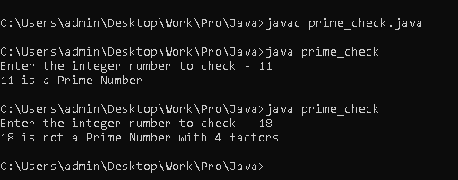

**Program 1.c**

**Aim:** To implement a program to demonstrate the working of types of operators(Bitwise, Logical and relational) using switch case.

**Theory:**

Relational Operators:

⦁== (Equal to)– This operator is used to check if both operands are equal.

⦁!= (Not equal to)– Can check if both operands are not equal.

⦁>(Greater than)– Can check if the first operand is greater than the second.

⦁< (Less than)- Can check if the first operand is lesser than the second.

⦁>= (Greater than equal to)– Check if the first operand is greater than or equal to the second.

⦁<= (Less than equal to)– Check if the first operand is lesser than or equal to the second

Logical Operators:

⦁&& (AND) – It is used to check if both the operands are true.

⦁|| (OR) – These operators are used to check if at least one of the operands is true.

⦁! (NOT) – Used to check if the operand is false

Bitwise Operators:

⦁ & (Bitwise AND) – Converts the value of both the operands into binary form and performs AND operation bit by bit.

⦁ | (Bitwise OR) – Converts the value of both the operands into binary form and performs OR operation bit by bit.

⦁ ^ (Bitwise exclusive OR) – Converts the value of both the operands into binary form and performs EXCLUSIVE OR operation bit by bit.

**Code:**

class Operators

{

public static void main(String args[])

{

int option =1;

int a, b;

a = 10;

b = 5;

switch(option)

{

case 1:

System.out.println("The value of a & b is "+ (a&b));

System.out.println("The value of a | b is "+ (a|b));

System.out.println("The value of a ^ b is "+ (a^b));

System.out.println("The value of ~a is "+ ~a);

System.out.println("The value of a<<2 is "+ (a<<2));

System.out.println("The value of a>>2 is "+ (a>>2));

break;

case 2:

System.out.println("The value of ((a>15) && (b<5)) is "+ ((a>15) && (b<5)));

System.out.println("The value of ((a>5) || (b<15)) is "+ ((a>5) || (b<15)));

System.out.println("The value of !((a>25) == (b<5)) is "+ !((a>25) == (b<5)));

break;

case 3:

System.out.println("The value of a == b is " + (a == b));

System.out.println("The value of a != b is " + (a != b));

System.out.println("The value of a > b is " + (a > b));

System.out.println("The value of a < b is " + (a < b));

System.out.println("The value of a >= b is " + (a >= b));

System.out.println("The value of a <= b is " + (a <= b));

break;

default:

System.out.println("Invalid Input");

break;

}

}

}

